

Data Flow Diagram

Date | 15 March 2026
Team ID | SWTID-2026-1506
Project Name | AI STUDY BUDDY
Maximum Marks | 2 Marks

Data Flow Diagram
Create a Data Flow Diagram (DFD) to show how data moves through your system - between external entities, processes, and data stores. Use the symbol legend below as a guide.

DFD Symbol Legend

Symbol | Name | Description
Oval / Rounded shape | External Entity | A person, organization, or system outside the project that sends or receives data (e.g., Customer, Payment Gateway).
Rectangle with numbered header | Process | An activity that transforms incoming data into outgoing data (e.g., Validate Request, Process Order).
Rectangle (solid fill, no number) | Data Store | A place where data is held for later use (e.g., Customer Database, Inventory).
Labeled arrow | Data Flow | The movement of data between entities, processes, and data stores, labeled with what data is being passed.

Example
The diagram below illustrates how the symbols above come together to form a complete data flow diagram.


SKILL WALLET
A SmartBridge Product

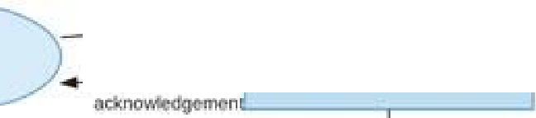
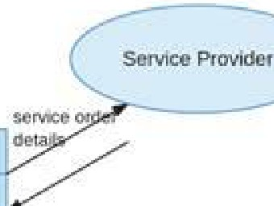
request
Requesl f-laridU119
User
Validate ReqLiesl
reque�1 and cu:;tomt'lr m.1cm11i1dcn
2 Fumnmenl
reque:itt:let.BJ!il
Requesl oa1as1ore
Process R!!QUBS!
i::Cnhn'Mlti0n
1:1nfl sle�updl;lile
°""''hlS!□iy
upd.ille IOCOICI
J Nmlllcatlon

NotilyUser
lnvenw,y

